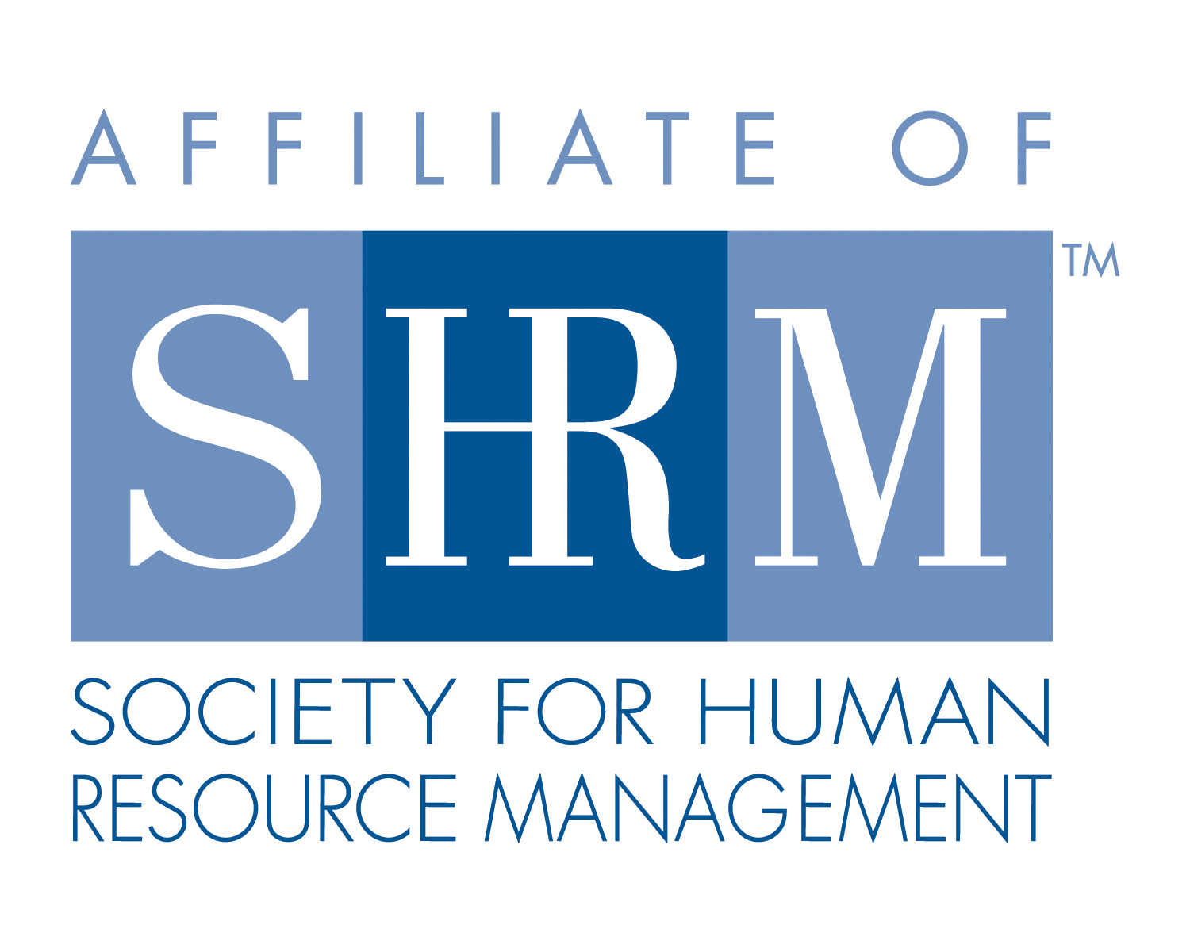
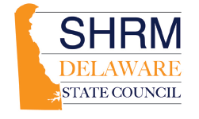
SHRM State Council Minutes
January 29, 2018

Attendees: Jon McDowell, Nicole Evans, Tricia Clendening, Jackie Poquette, Ashley Eckard, Phyllis Shurn-Hannah, Amanda Novak, Mary Beth Dockety, Melissa Cullen, Cindy Crompton-Barone, Laurie Sample
Welcome –November 2017 planning meeting minutes were approved and seconded. Motion made by Jon McDowell, Seconded by Nicole Evans
Melissa Cullen – DelMarVa SHRM Chapter Update

January 2018 Meeting was entitled “Can We Do That? Practical Answers to Frequently Asked HR Questions (Panel discussion)

February meeting will be held on February 20, 2018 at Dover Downs entitled “Hire the Best and Make Them Better/”
Melissa is on the committee working on the Diversity Workshop planning in July.
Ashley Eckard Delaware SHRM Chapter Update
January’s meeting, Develop Your Executive Presence was well attended and feedback was favorable.
Conference plans underway, Keynotes booked, Sara McBride, Jennifer McClure. Will be working on obtaining presentations for promotion.
Bette Francis will be the conference co-chair. Call for Speakers is now closed. Selection process to begin shortly. Email will be sent out soon for volunteers to assist in speaker selection, sponsorship, etc.
Diversity Workshop scheduled for July 10, 2018
April’s meeting will be a Legal Workshop as a joint chapter effort in Dover.

Tricia Clendening Financial Update – Do you have these numbers?
Profit share from state conference has not been given to date.

Phyllis Shurn-Hannah – SHRM Update
Went over SHRM staff support. Crystal Adair is Northeast Region membership liaison.
Shape due January 31, Excel due March 15th, 2018
Stressed importance of communicating with member regarding recertification especially for those who joined as part of Pathways as they all will expire this year.
State Council and Chapter receive incentives for recertification. Monies were given for all members who are certified in the past.
Volunteer Summit Nov 15-17 at the Gaylord National in Washington, DC.
Annual Conference June 17-20 in Chicago
December 1st - State council and chapter CLIF is due
Conference discount for chapter volunteers’ deadline is February 2, 2018
Foundation Scholarship available for SHRM conferences, Diversity etc. Opportunities for volunteers and members.
Johnnie Taylor new CEO and President. Video on website.
VLS is being redesigned, user friendly. New toolkits out soon.
Thank you to all SHRM volunteers.

2018 initiatives and decide on 2018 Key Initiatives were discussed and voted on.

Become highly recognized by Federal, State and Local lawmakers and regulators as their preferred source for input and feedback.
Hold State Council sponsored events
Promote and market SHRM Certification for the State by partnering with colleges and universities, study groups (in person and online). Host an informational networking event and explain what SHRM certification is and how to get started and be a successful HR professional.
Become highly recognized by Federal, State and Local lawmakers and regulators as their preferred source for input and feedback.
Focus on Legislation and Regulation
In collaboration or partnership with local chapters, provide outreach to emerging HR professionals and assist with mentoring and developing them into leadership positions.
Identify and develop opportunities to engage Emerging Professionals
Engage all levels of HR professionals in and around the state of Delaware in collaboration with local chapters
Increased COLLABORATION and coordination with other professional organizations.
Develop, reignite and support student chapters at all higher education institutions in the area.
Develop initiatives for engaging and supporting Student Chapters

Tricia Clendening – State Council Update
March 23rd ½ day workshop, Topic will be of interest to HR professionals and C-Suite
Presentation on Coaching – The Business Perspective of Coaching. Transition into new roles through coaching.
Confirmation pending. Still looking at location and costs. PR through chapters and email blasts.
State Council Board members invited at no cost
Shape - submitted
Discount for new SHRM members – code 0118
Student Engagement Toolkits – possibility of working with another state
New Certification Resources -
Regional Council Meeting –

Jackie and Jon working on legislative update to include HB299
Open for any suggestions on what to add

Action Item Send by 19th any suggestions on how to implement the initiatives

Adjourn – Motion by Jon and seconded by Melissa at 1:04 pm
Next meeting: February 26th 12:00 to 1:00 pm

